SET 30 – MOBILE APP USAGE ANALYSIS
AIM
To analyze mobile application usage using R programming and Tableau-style visualizations, including a histogram, density plot, scatterplot, and bar chart.
DATASET
User_ID | Gender | Age | Screen_Time | App_Usage_Count | Data_Used | Satisfaction | Usage_Date
U01 | Male | 20 | 4.5 | 18 | 2.4 | 3 | 2025-01-08
U02 | Female | 22 | 6.0 | 25 | 3.8 | 5 | 2025-01-08
U03 | Male | 19 | 3.2 | 12 | 1.6 | 3 | 2025-02-11
U04 | Female | 21 | 7.1 | 30 | 4.5 | 5 | 2025-02-11
U05 | Male | 23 | 2.8 | 10 | 1.2 | 2 | 2025-03-14
U06 | Female | 20 | 5.4 | 22 | 3.1 | 4 | 2025-03-14
PROGRAM 1: Histogram and Density Plot of Screen Time
Aim: To visualize the distribution of users' screen time.
R Program:
screen <- c(4.5,6.0,3.2,7.1,2.8,5.4)
hist(screen, probability=TRUE,
col="skyblue", border="white",
main="Screen Time Distribution",
xlab="Screen Time (hours)",
ylab="Density")
lines(density(screen), col="red", lwd=2)
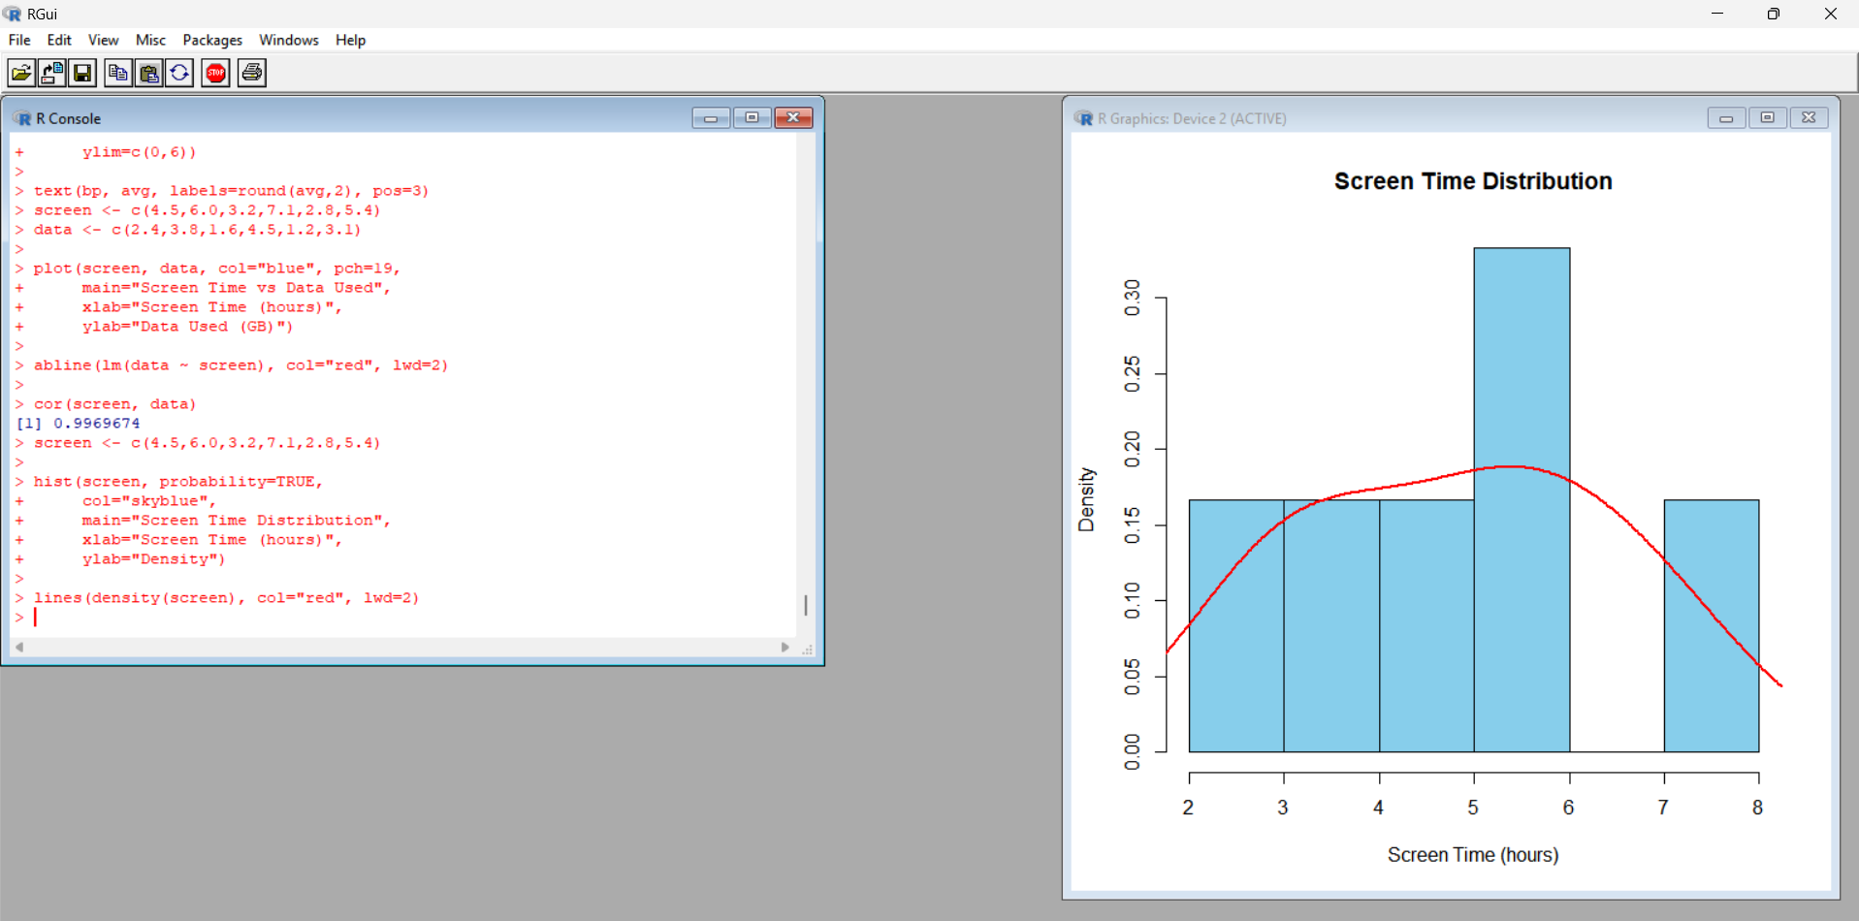
Observation: Screen time ranges from 2.8 to 7.1 hours. The histogram and density curve show the distribution of screen time among the six users.
Result: The screen-time distribution was visualized using a histogram and density curve.
PROGRAM 2: Scatterplot of Data Used vs Screen Time
Aim: To examine the relationship between screen time and data usage and calculate their correlation.
R Program:
screen <- c(4.5,6.0,3.2,7.1,2.8,5.4)
data_used <- c(2.4,3.8,1.6,4.5,1.2,3.1)
plot(screen, data_used,
col="blue", pch=19,
main="Screen Time vs Data Used",
xlab="Screen Time (hours)",
ylab="Data Used (GB)")
abline(lm(data_used ~ screen), col="red", lwd=2)
cor(screen, data_used)
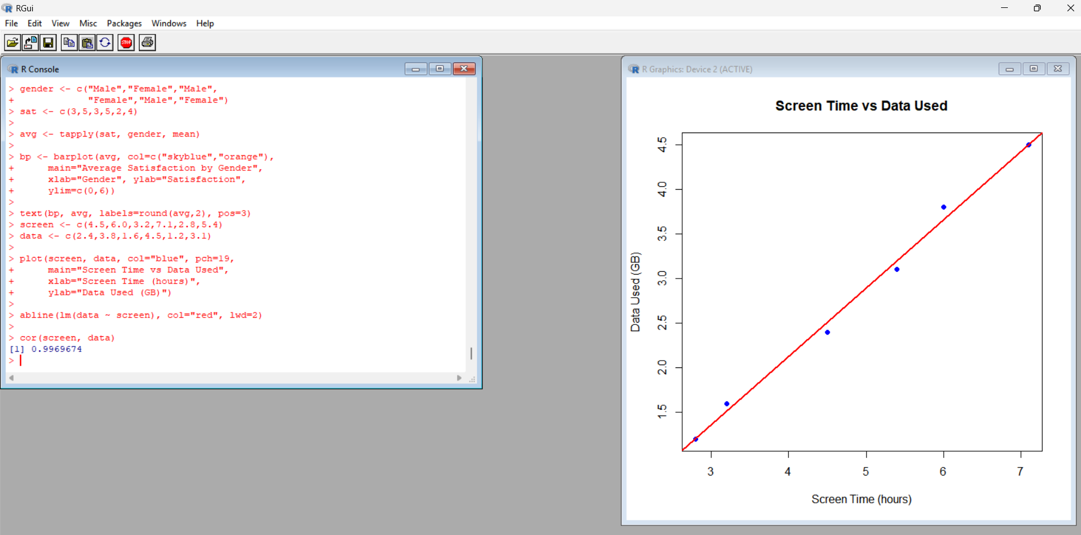
Observation: The scatterplot shows a positive relationship: users with higher screen time generally use more mobile data. The correlation is approximately 0.99.
Result: The scatterplot and correlation analysis indicate a strong positive association between screen time and data usage.
PROGRAM 3: Average Satisfaction by Gender
Aim: To calculate average satisfaction scores for male and female users and display them using a bar chart.
R Program:
gender <- c("Male","Female","Male",
"Female","Male","Female")
satisfaction <- c(3,5,3,5,2,4)
avg <- tapply(satisfaction, gender, mean)
bp <- barplot(avg,
col=c("skyblue","orange"),
main="Average Satisfaction by Gender",
xlab="Gender",
ylab="Average Satisfaction",
ylim=c(0,6))
text(bp, avg, labels=round(avg,2), pos=3)
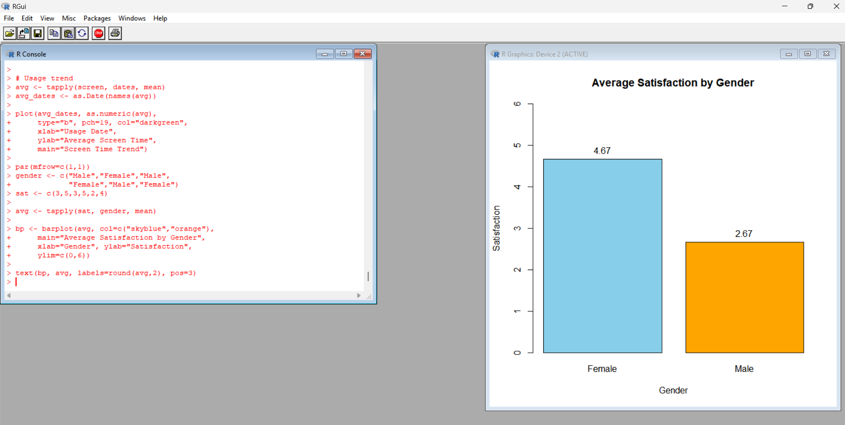
Observation: The average satisfaction score for male users is 2.67, while the average for female users is 4.67. Female users have a higher average satisfaction score in this sample.
Result: The bar chart compares average satisfaction by gender.
PROGRAM 4: Mobile App Usage Dashboard Using R Studio
Aim: To create a dashboard-style visualization combining screen time, data usage, gender, app usage count, and usage trends using R Studio.
R Program:
user <- c("U01","U02","U03","U04","U05","U06")
gender <- c("Male","Female","Male",
"Female","Male","Female")
screen <- c(4.5,6.0,3.2,7.1,2.8,5.4)
data_used <- c(2.4,3.8,1.6,4.5,1.2,3.1)
apps <- c(18,25,12,30,10,22)
dates <- as.Date(c("2025-01-08","2025-01-08",
"2025-02-11","2025-02-11",
"2025-03-14","2025-03-14"))
par(mfrow=c(1,2))
# Bubble chart
plot(screen, data_used,
pch=19, col=ifelse(gender=="Male","blue","red"),
cex=apps/10,
xlab="Screen Time (hours)",
ylab="Data Used (GB)",
main="Screen Time vs Data Used")
text(screen, data_used, labels=user, pos=3)
legend("topleft", c("Male","Female"),
col=c("blue","red"), pch=19)
# Usage trend
avg_screen <- tapply(screen, dates, mean)
plot(as.Date(names(avg_screen)), avg_screen,
type="b", pch=19, col="darkgreen",
xlab="Usage Date",
ylab="Average Screen Time",
main="Screen Time Trend")
par(mfrow=c(1,1))
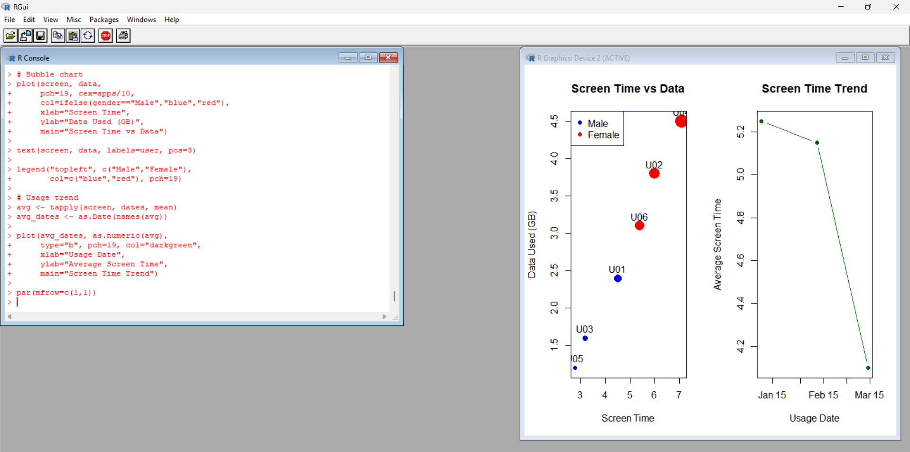
Observation: The bubble chart compares screen time and data usage, with bubble size representing app usage count and color distinguishing gender. The trend chart shows average screen time for each usage date.
Result: A dashboard-style visualization was created in R Studio to compare mobile app usage patterns.

